JSX stands for JavaScript XML.

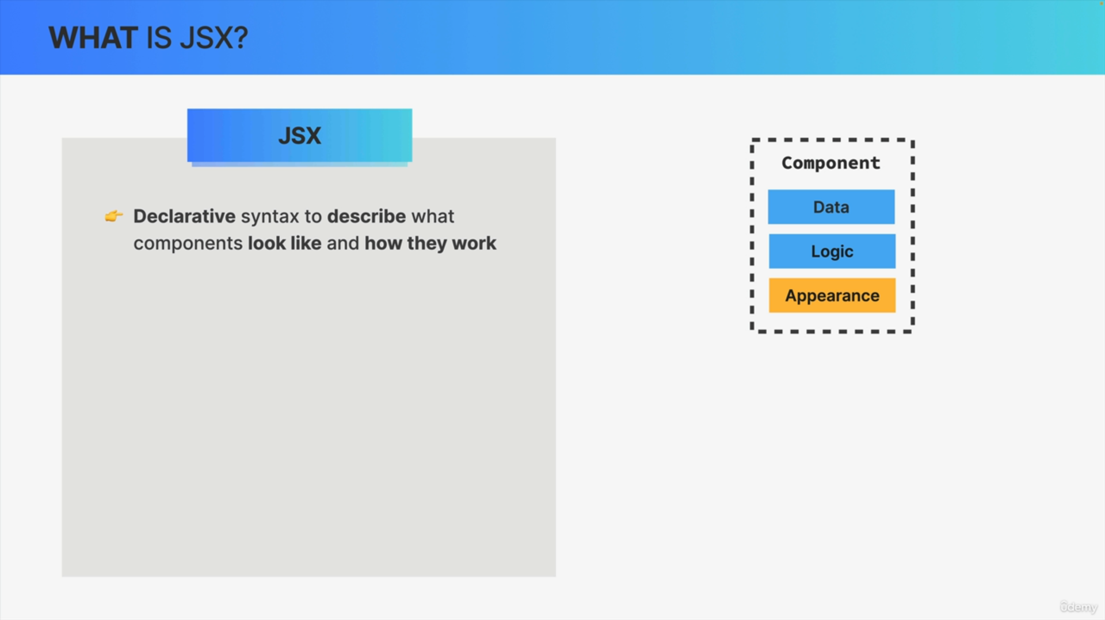

JSX is a declarative syntax which is used to describe what components look like and how they work based on their data and logic.

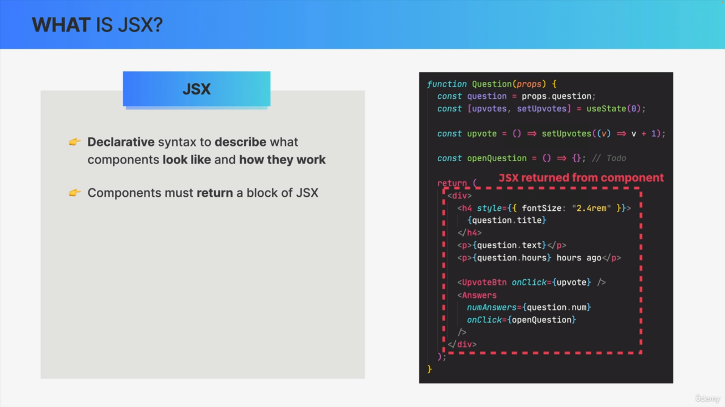

Each component should return a block of JSX which is used by REACT to render the component on the UI.

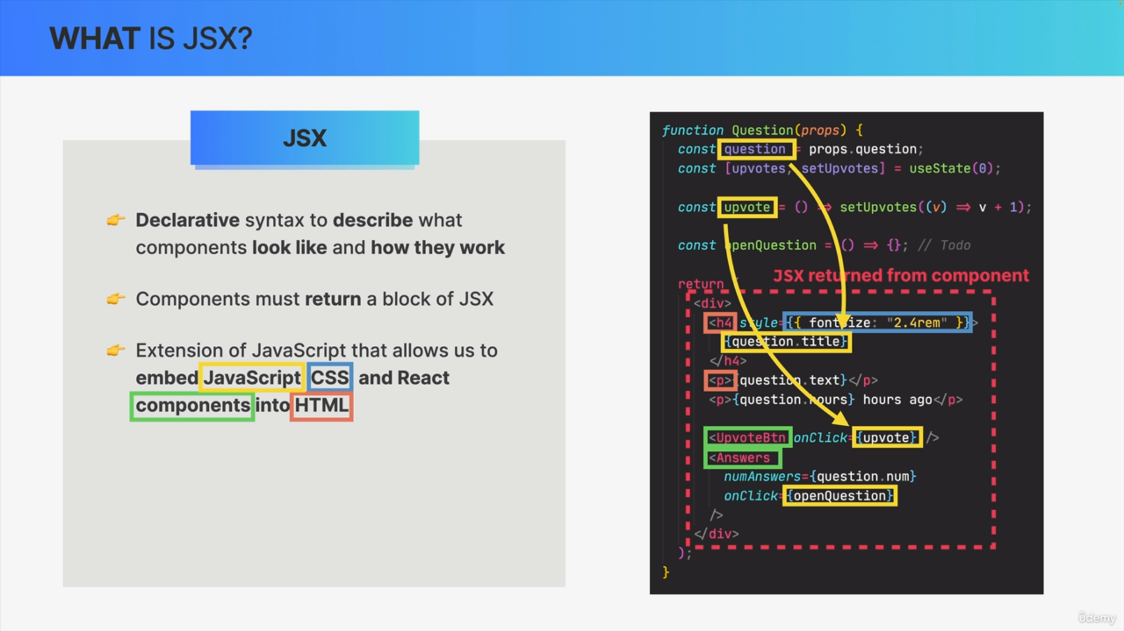

JSX is an extension of JAVASCRIPT which allows us to combine parts of HTML, CSS and JAVASCRIPT all into one block of code. We can write HTML and embed some piece of JAVASCIPT when necessary.

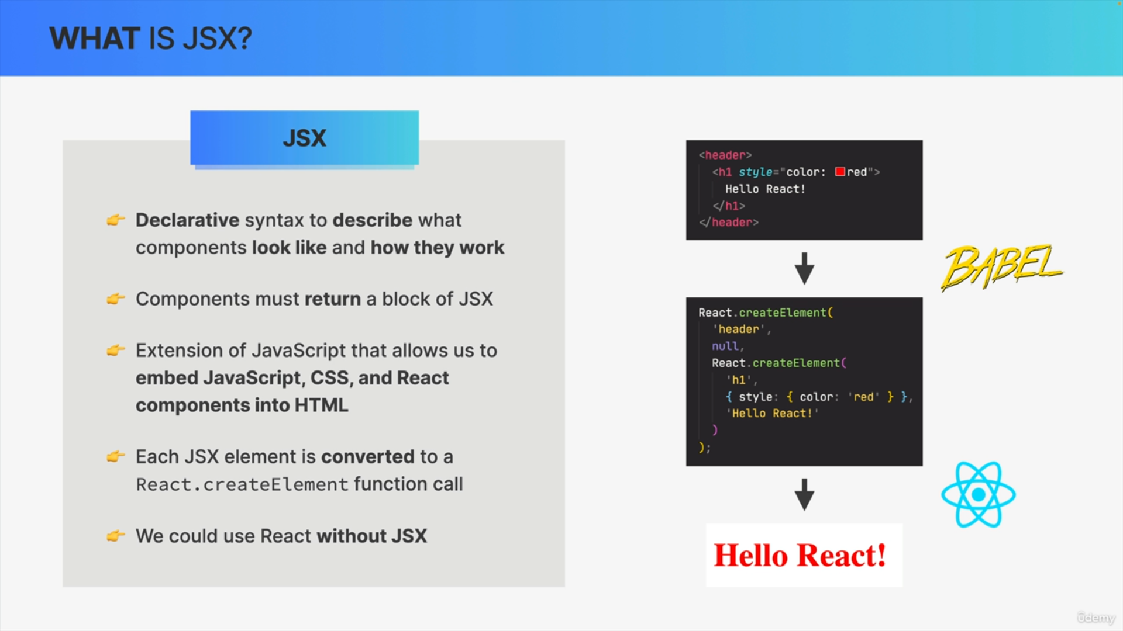

Q: If REACT is a JAVASCRIPT library, how does it understand this JSX?

A: There is a simple way of converting JSX into JAVASCRIPT. This is done by a tool called a BABEL which gets automatically included into our application by CREATE-REACT-APP.

Each JSX code gets converted into React.createElement() function call. This conversion is necessary because browsers do not understand JSX. They only understand HTML. All the JSX gets converted into many nested React.createElement() function calls behind the scenes. These function calls create the HTML elements that we see on the screen.

We can use REACT without JSX. We can manually create React.createElement() function calls instead of JSX.

1. This makes the code very hard to read and understand.
2. Everyone uses the JSX way.

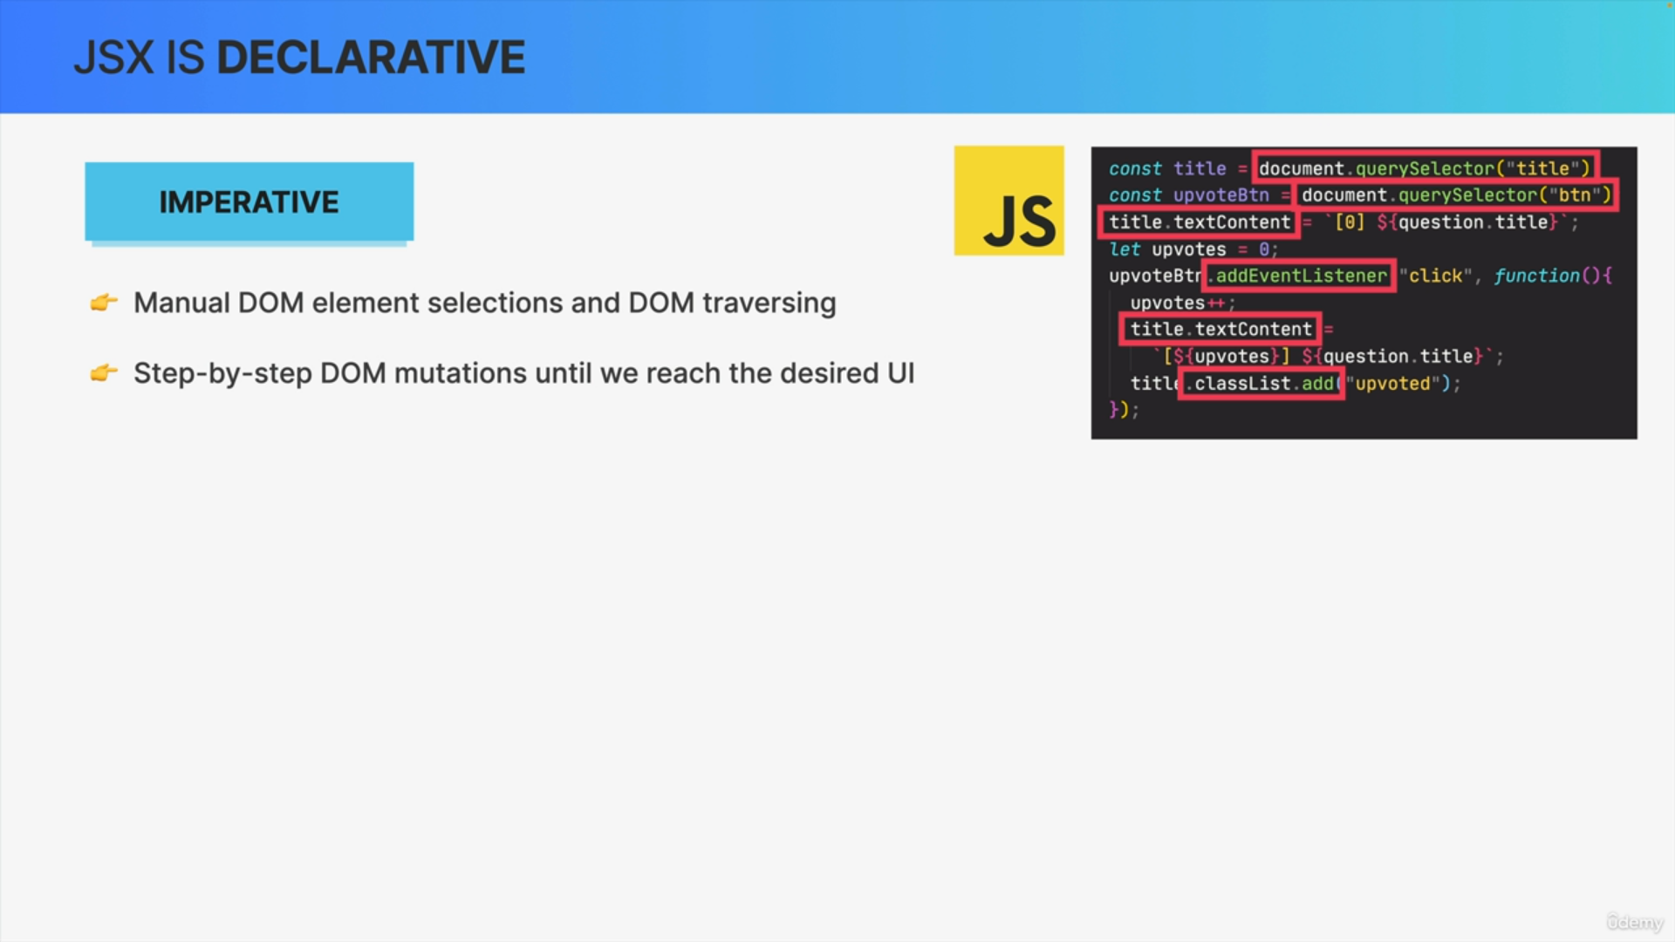

When we build UI using vanilla JAVASCRIPT, we are using imperative approach by default. Imperative approach basically tells how to do things.

1. We manually select DOM, traverse the DOM and attach event handlers to elements.
2. If something happens in the app, like click on button we give the browser step by step instructions on how to mutate those DOM elements until we reach the desired and updated UI.

In a complex application like AIRBNB it is not feasible.

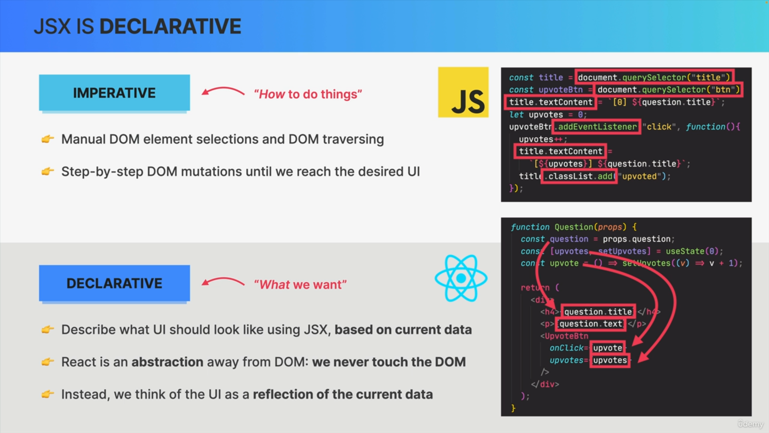

1. A declarative approach describes what UI should look like. We use the JSX to describe the UI based on current data.
2. All this happens without any DOM manipulation. REACT is an abstraction away from DOM.
3. We think of UI as reflection of current data and let REACT automatically synchronize the UI with that data.